PROJECT REPORT
ON
Student Management System
in partial fulfillment of
Continuous Internal Assessment
Cloud Application Development Lab Course

BACHELOR OF TECHNOLOGY
IN
COMPUTER SCIENCE & ENGINEERING

Submitted by

Debneet Balabantaray ENG20CS0422
Jasraj Singh ENG20CS0423
Vivek Belagali ENG20CS0414

Under the supervision of
Prof. Pradeep Kumar
Professor of Cloud Application Development

Dept of Computer Science and Engineering, SoE


DAYANANDA SAGAR UNIVERSITY
KUDLU GATE, BANGALORE - 560068

DAYANANDA SAGAR UNIVERSITY
KUDLU GATE, BANGALORE - 560068

CERTIFICATE

This is to certify that the project report entitled “ Student Management System ” by Debneet Balabantaray, Jasraj Singh, Vivek Belagali bearing USN number ENG20CS0422, ENG20CS0423, ENG20CS0414 respectively is submitted as a continuous Internal Evaluation component for the course “Cloud Application Development Lab” with the Course Code “20CS3605”, 6th semester, Computer Science and Engineering Program’s Bachelor of Technology degree for the academic year 2023.
DEBNEET BALABANTARAY | ENG20CS0422 | 6TH SEMESTER F SECTION
JASRAJ SINGH | ENG20CS0423 | 6TH SEMESTER F SECTION
VIVEK BELAGALI | ENG20CS0414 | 6TH SEMESTER F SECTION

.

Date:

Signature of the Faculty in Charge

Signature of the Chairman

ABSTRACT

A student management system is an application designed to manage student data such as student details, courses, attendance, grades, and academic performance. This system can be developed using PHP, a popular scripting language for web development. The system can provide a user-friendly interface for both students and administrators to manage the student information.

The student management system using PHP typically includes a database to store student data, a front-end interface for user interaction, and back-end logic to handle data processing. The system can allow students to view their academic information, course schedule, attendance records, and grades. The system can also allow administrators to add, modify, and delete student information and generate reports based on various criteria.

The key features of a student management system using PHP may include login and authentication, student profile management, course management, attendance tracking, grade management, report generation, and communication with students and faculty. The system can also incorporate features such as notifications for important events and reminders for deadlines.

Overall, a student management system using PHP can provide an efficient and effective way to manage student data and improve communication between students and administrators.

Table of Contents

10
Abstract
Table of Contents
1. Introduction | 1
Problem Statement
2. Requirement Specification | 2
2.1 Introduction
2.2 Software Requirement Specification
2.2.1 Frontend Requirement Specification
2.2.2 Backend Requirement Specification
3. Analysis and Design | 5
3.1 Flowchart Structure

3.2 Functional Description of major modules
3.2.1 Module1
3.2.2 Module 2
4. Implementation | 7
4.1 Programming language for implementation
4.2 Data structures/packages used/libraries used
5. Applications and Conclusion | 8
5.1 Applications
5.2 Conclusion
6. Snapshots

1. Introduction

Problem Statement :-

Many educational institutions struggle with managing and organizing student data, including personal details, academic performance, attendance records, and course schedules. Traditional paper-based record-keeping systems can be time-consuming, inefficient, and prone to errors. As a result, there is a need for a more modern, automated system to manage and store student data.

The problem is that current student management systems lack the necessary functionality to effectively manage and organize student data. Many systems are outdated and difficult to use, and may not provide administrators and educators with real-time access to student information. Additionally, these systems may not be scalable or adaptable to changing needs and requirements.

There is a need for a modern, web-based student management system that can efficiently manage and store student data, provide real-time access to student information, and improve communication between students, educators, and administrators. This system should be user-friendly, scalable, and customizable to meet the needs of different educational institutions.

2. Requirement Specification

2.1 Introduction

The Student Management System (SMS) is a web-based application that allows educational institutions to manage their student-related data efficiently. The system provides an easy-to-use interface for administrators, teachers, and students to access and update information related to enrollment, attendance, grades, and more.

The SMS is built using PHP programming language, which is a popular choice for web development due to its simplicity, flexibility, and scalability. It also uses MySQL as the database management system to store and retrieve data efficiently.

The SMS can help educational institutions streamline their operations and reduce the administrative burden associated with managing student data. With features such as attendance tracking, grade management, and course scheduling, the system can provide real-time access to important information, allowing educators to make informed decisions about their students' progress.

Furthermore, the web-based nature of the SMS means that it can be accessed from anywhere, at any time, making it convenient for both students and educators. The system can also be customized to meet the specific needs of different institutions, ensuring that it remains relevant and useful over time. Overall, the SMS is a powerful tool for educational institutions looking to modernize their student management processes and improve the quality of education they provide.

2.2 Software Requirement Specification

- Software: XAMPP
- Web Server: Apache
- Database Management System: MySQL
- Programming Language: PHP5.6, PHP7.x
- HTML and CSS: for designing the user interface
- JavaScript: for adding interactivity and dynamic features to the interface
- Visual Studio Code: for writing and editing the code

2.2.1 Frontend Requirement Specification

- User Interface Design: The system should have a modern, intuitive user interface design that is easy to navigate for users of all levels. The design should be consistent across all pages of the system.

- Dashboard: The system should have a dashboard that provides an overview of important information, such as class schedules, notices, and personal details. The dashboard should be customizable so that users can personalize it to their needs.

- Navigation: The system should have a clear and easy-to-use navigation system that allows users to quickly access the different features and functionalities of the system.

- Student Profile: The system should have a student profile page that displays information such as name, contact information, academic history, and progress reports. The profile page should also allow users to update their information.

- Class Management: The system should have a class management section that allows educators to add and manage class information, such as class name, section, and class creation date.

- Communication: The system should have a communication section that allows users to communicate with each other via email or messaging.

2.2.2 Backend Requirement Specification

- Programming Language: The project will be developed using PHP 5.6 or PHP 7.x.

- Database Management System: MySQL 5.x will be used to manage the database of the system.

- Server: XAMPP is used as the web server to host the application.

- Framework: Any PHP framework like Laravel, CodeIgniter, or CakePHP can be used for developing the project.

- Libraries: AJAX, jQuery, JavaScript, and HTML will be used to create the user interface of the system.

- Security: The system must be secured with a strong password encryption algorithm and protected from SQL injection attacks.

- APIs: APIs can be used to integrate the system with other third-party applications.

- User Authentication: The system should have a user authentication module that will allow only authorized users to access the system.

- Data Management: The system must be capable of managing data related to students, classes, notices, and other relevant information.

- Reporting: The system should be able to generate reports that provide insight into the performance of students and their progress.

3. Analysis and Design

3.1 Flowchart Structure

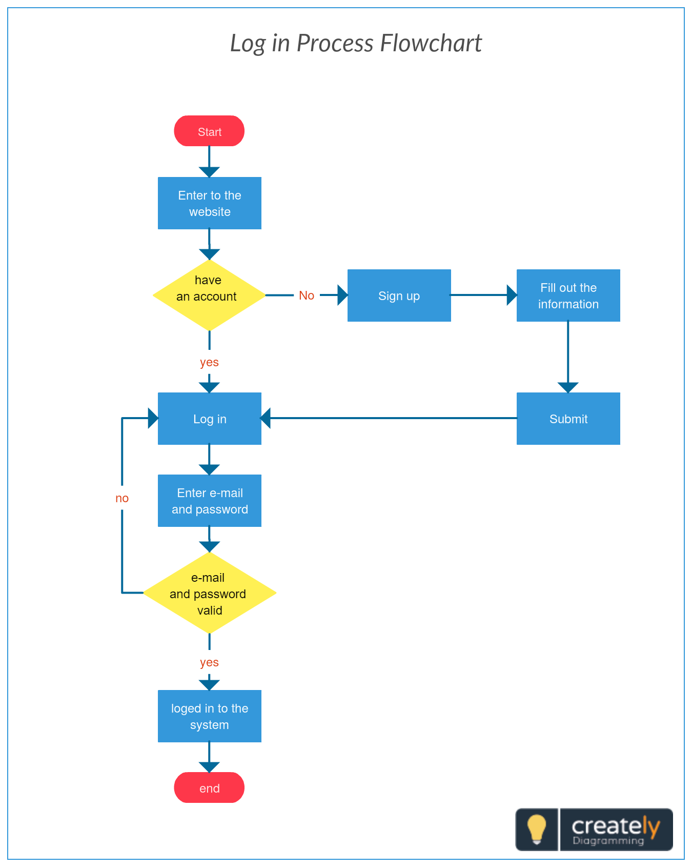

Fig.No 1 :- Flowchart For Landing page

3.2 Functional Description of major modules

3.2.1 Module1

- User (Students):
- Dashboard: It is welcome page for students.
- View Notices: In this section, user can view notices which are announced by administrator.
- Student can also view his profile, change the password and recover the password.
- User (Non-Register):
- Home: It is welcome page for user.
- About: User can view about us page.
- Contact: User can view contact us page.

3.2.2 Module 2

- Admin:
- Dashboard: In this section, admin can see all detail in brief like Total Classes, Total Students, Total Class Notices and Total Public Notices.
- Class: In this section, admin can manage class (Add/Update/Delete).
- Students: In this section, admin can manage the students (Add/Update/Delete).
- Notices: In this section, the admin can manage notices (Add/Update/Delete).
- Public Notices: In this section, the admin can manage public notices.
- Pages: In this section admin, can manage about us and contact us page of administration
- Search: In this section admin, can search students by their student id.
- Reports: In this section admin, can view how much students has been register in particular period.
- Admin can also update his profile, change the password and recover the password.

4. Implementation

4.1 Programming language for implementation

The programming language used for the implementation of this Student Management System project is PHP, with MySQL as the database management system. The user interface is designed using HTML, AJAX, jQuery, and JavaScript.

4.2 Data structures/packages used/libraries used

- Data Structures:

- Arrays: for storing and manipulating data
- Linked lists: for dynamic storage of data
- Stacks and Queues: for organizing data in a particular way
- Trees: for hierarchical organization of data

- Packages/Libraries:

- jQuery UI: for creating user interfaces and interactions
- Bootstrap: for creating responsive and mobile-friendly designs
- DataTables: for displaying and manipulating tabular data in HTML tables
- Chart.js: for creating interactive charts and graphs
- Typeahead.js: provides a fast and fully-featured autocomplete/autosuggest function for text input fields.
- PerfectScrollbar: allows for easy creation of custom scrollbar styles and behavior on web pages.
- Moment.js: used for parsing, validating, manipulating, and displaying dates and times.

- Database Management System:

- MySQL: for creating and managing the database

5. Applications and Conclusion

5.1 Applications

Efficient management of student records: The system provides an efficient way of managing student records and details such as personal information, academic records, attendance, and performance.

Easy communication: The system provides a platform for easy communication between students and administration through announcements, notices, and messages.

Time-saving and cost-effective: The system eliminates the need for manual record-keeping, which saves time and reduces the cost of paper-based records.

Improved accuracy: The system provides accurate and up-to-date information about students and their academic records, which helps in making informed decisions.

Improved performance: The system provides tools for tracking student performance, which helps in identifying areas of improvement and offering personalized support to students.

Increased transparency: The system provides transparency in the management of student records and activities, which builds trust and confidence among stakeholders.

Better decision-making: The system provides administrators with real-time data and analytics, which helps in making better decisions and improving the overall performance of the institution.

5.2 Conclusion

In conclusion, the Student Management System using PHP and MySQL is a web-based application that simplifies the management of students and their activities. The system offers various features for both the students and the administrators, including managing classes, students, notices, and public notices. The project uses PHP5.6 or PHP7.x as the programming language, MySQL 5.x as the database, and HTML, AJAX, JQUERY, and JAVASCRIPT for the user interface design. The system is beneficial for both students and school authorities as it eliminates the need for manual processes, which are time-consuming and costly. By following the steps provided, users can easily install and run the system on their local server. Overall, the Student Management System is an efficient tool for managing student-related activities, and its implementation can streamline school operations.

6. Snapshots

Home Page

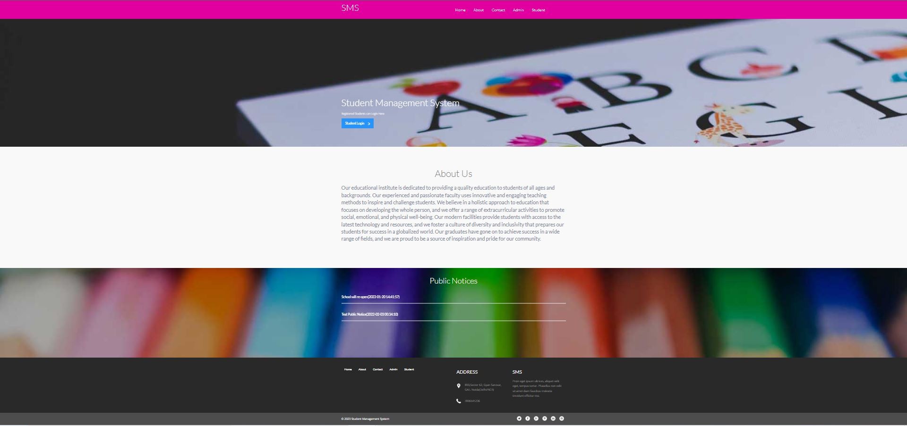

Login

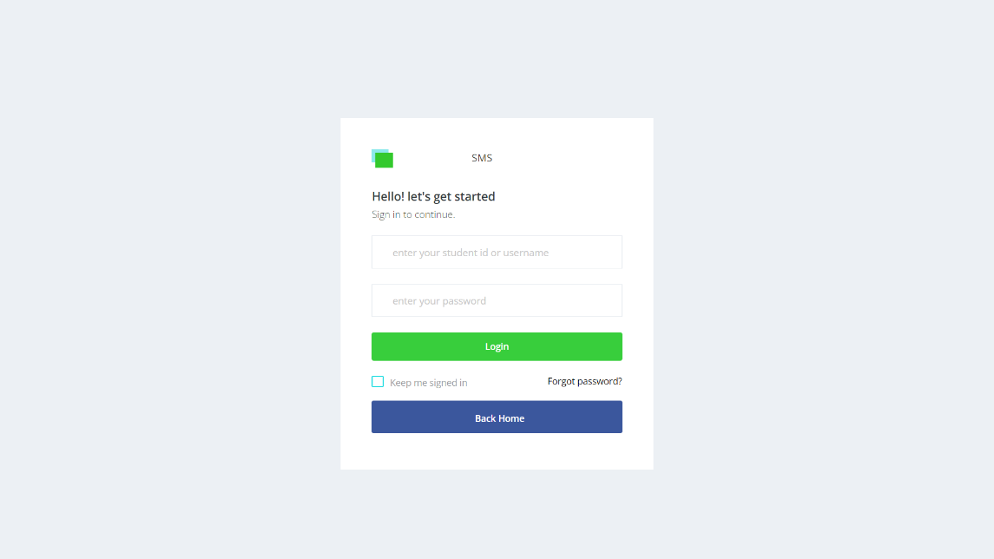

Student Dashboard
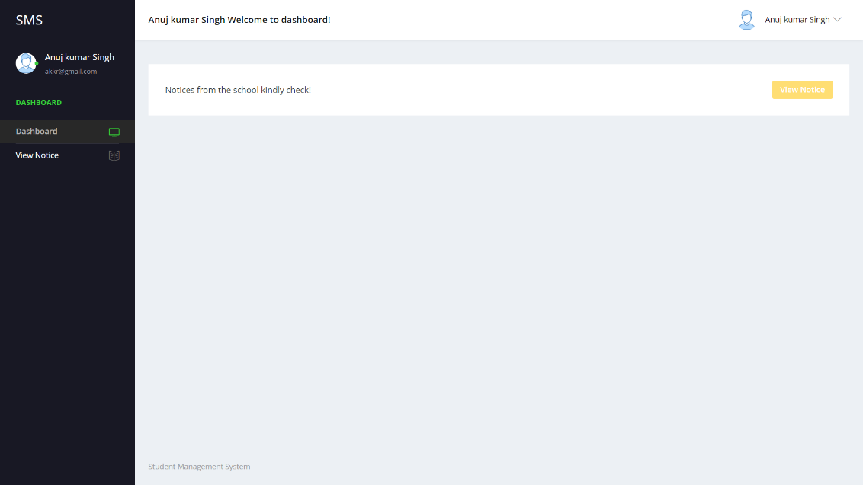

View Notice

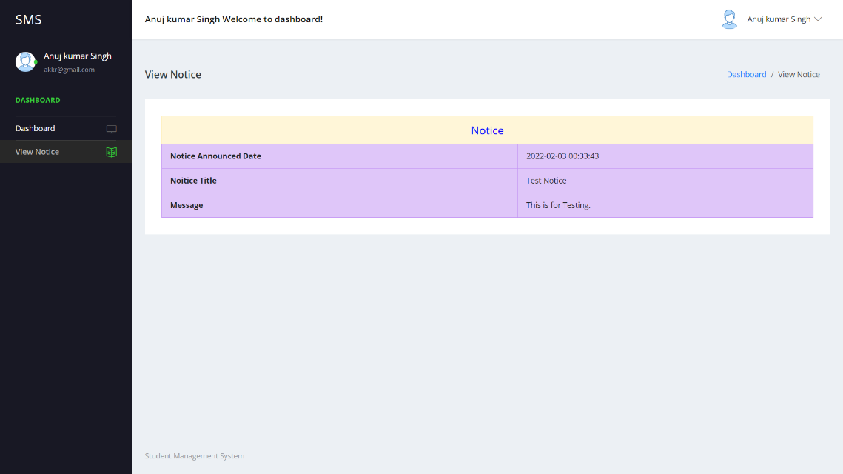

Admin Dashboard

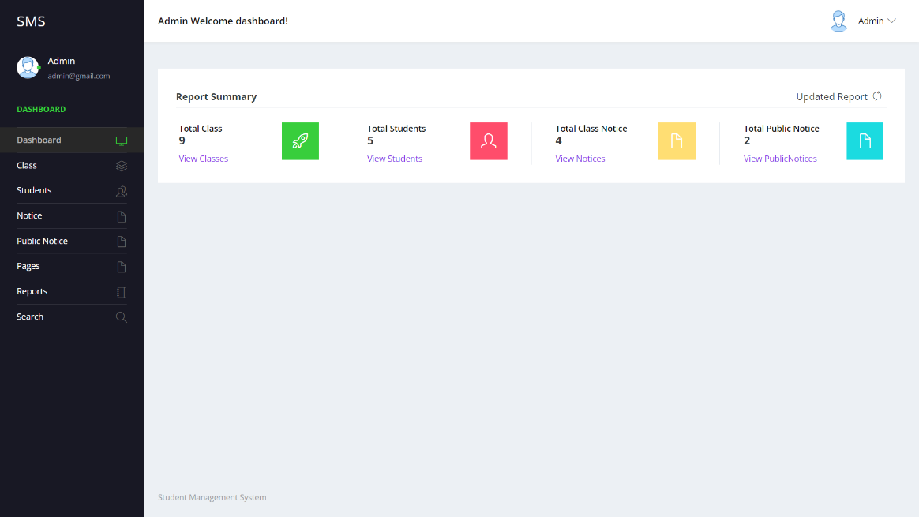

Add Class

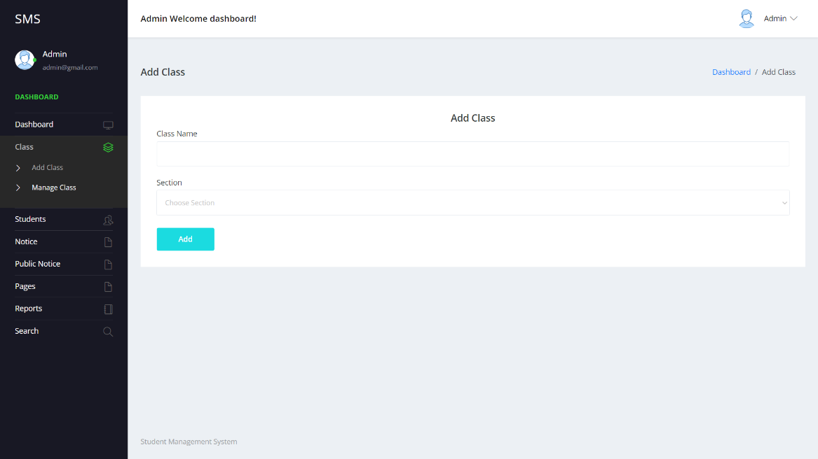

Manage Class

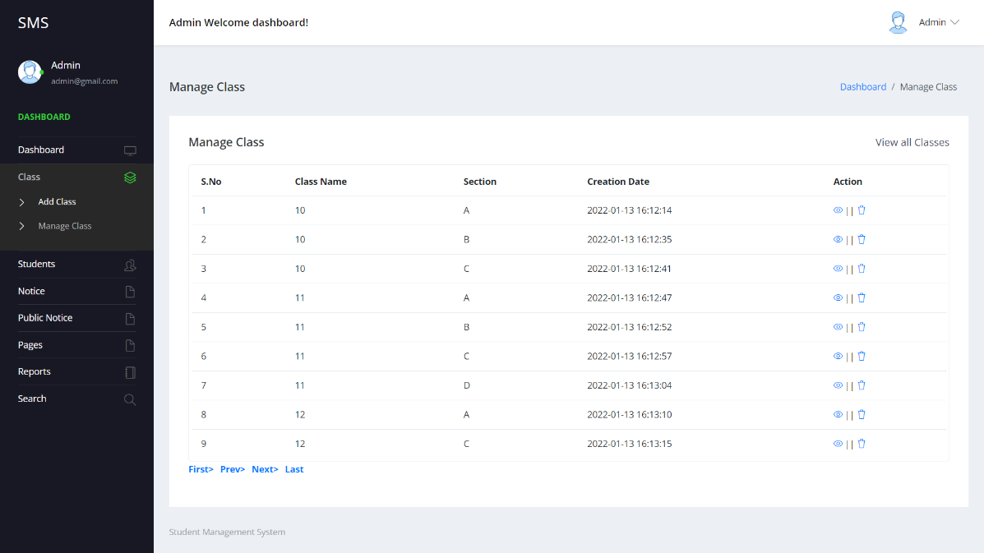

Add Students

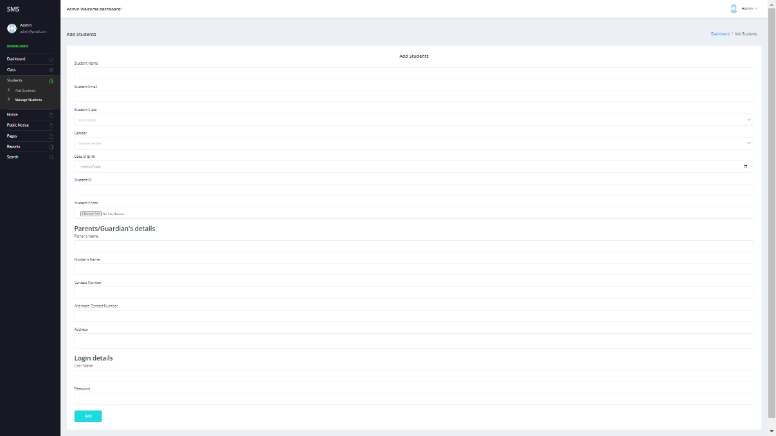

Manage Students

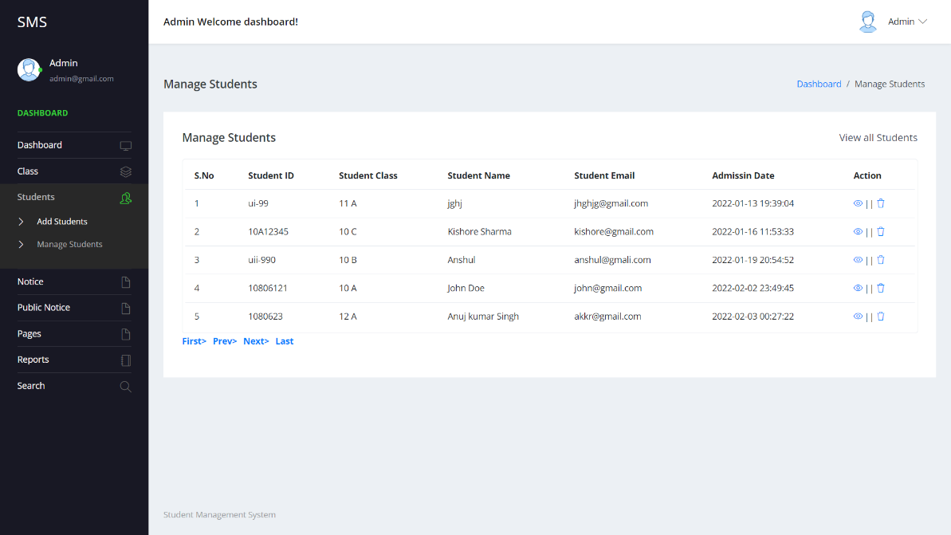

Add Notice

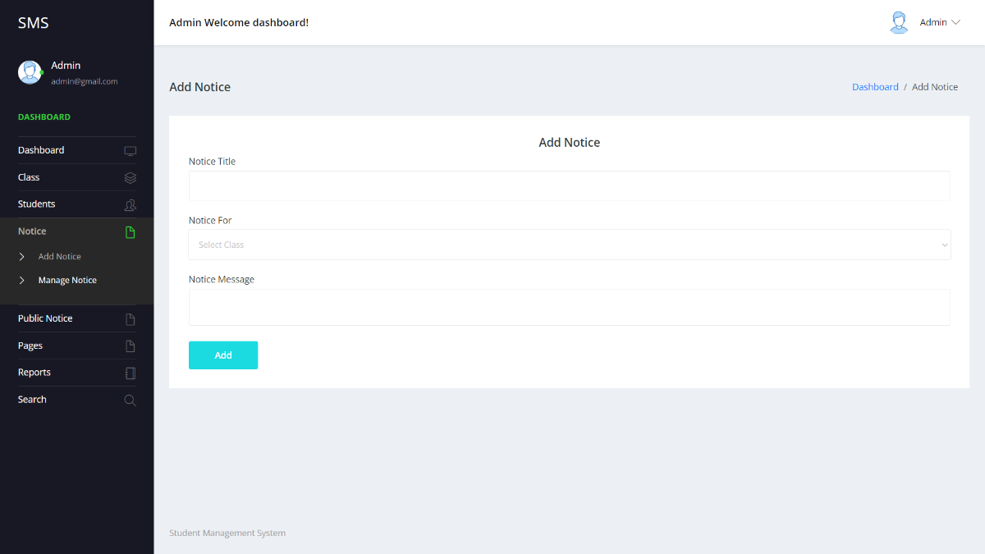

Manage Notice

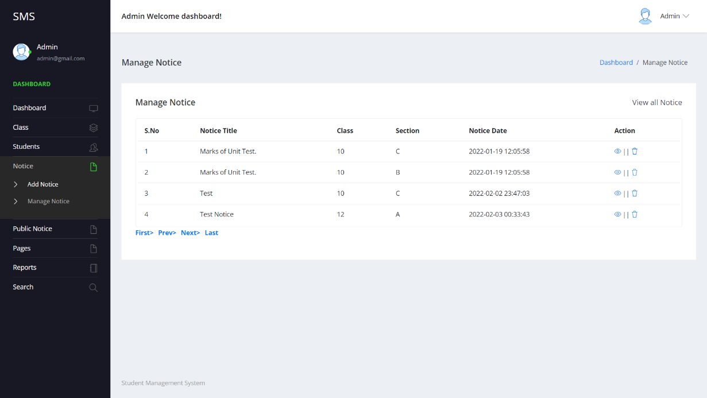

Add Public Notice

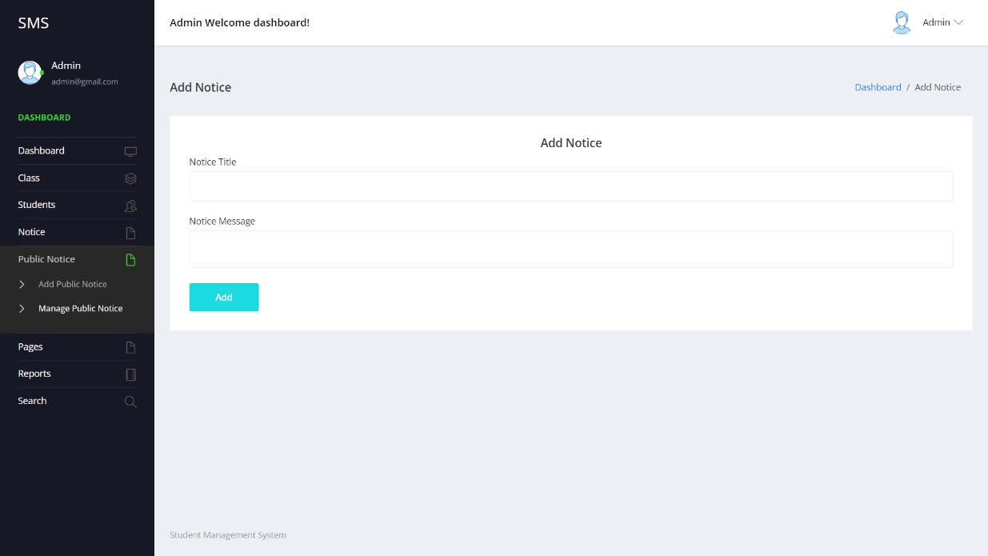

Manage Public Notice

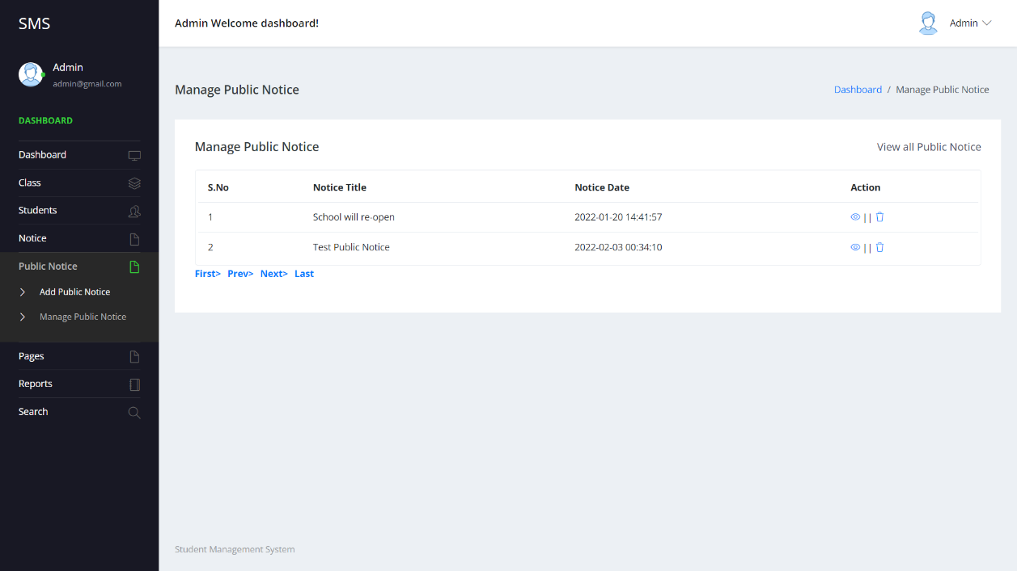

Update About Us

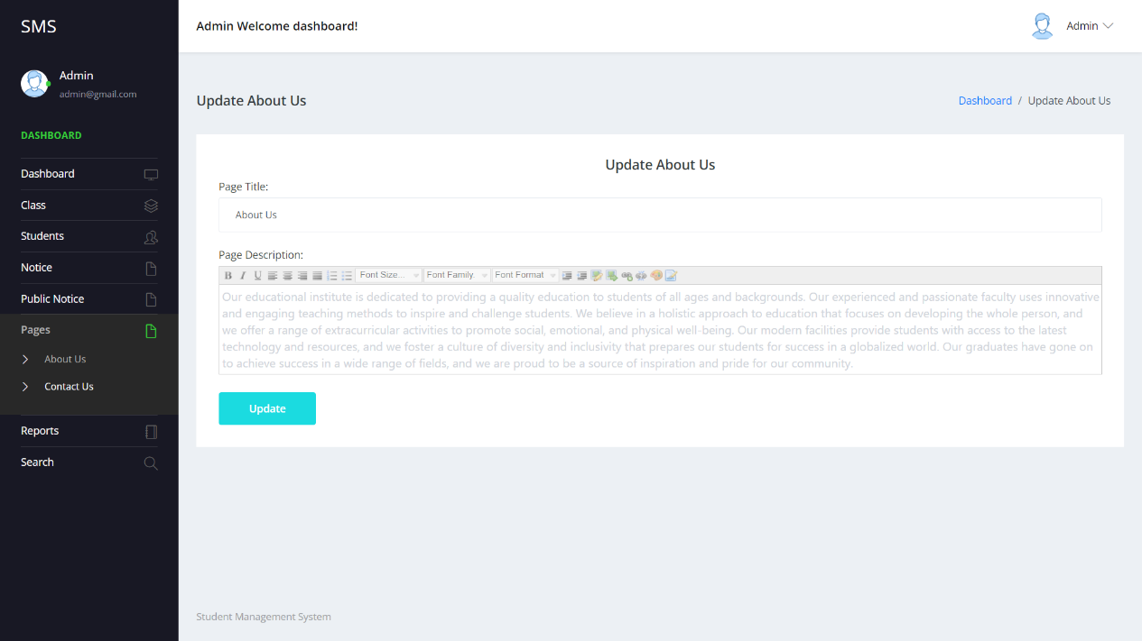

Update About Us

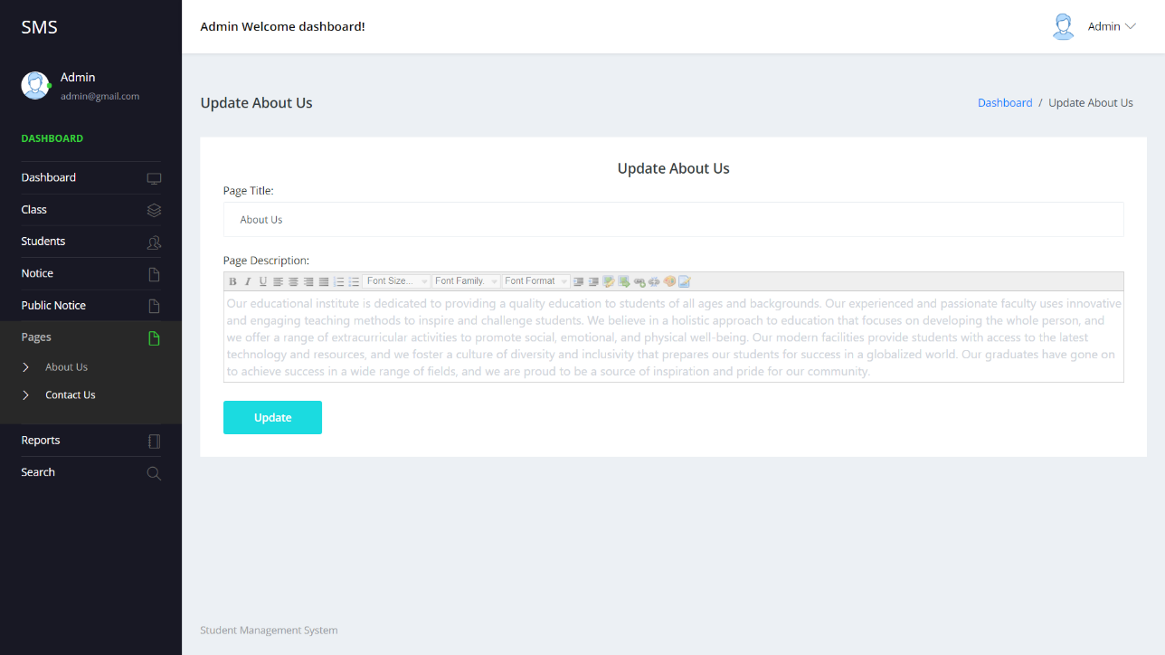

Reports

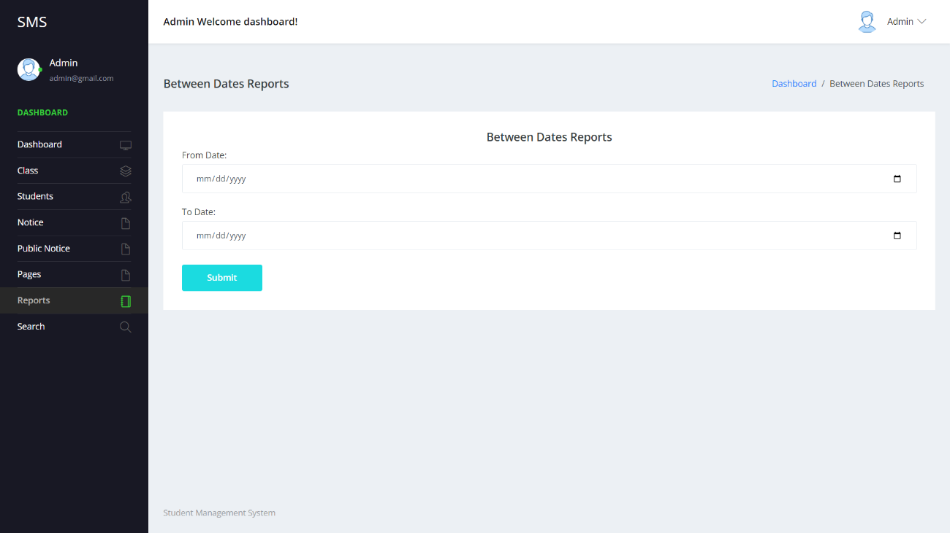

Search Students

